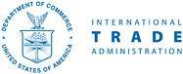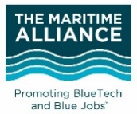 Apply Online by Dec. 16

U.S. Maritime Technology export initiative

# apply online by december 16, 2016

**The Maritime Alliance (TMA)** has partnered with the U.S. Department of Commerce, International Trade Administration to organize and partially fund an initiative to increase exports from small maritime technology companies (typically $2MM revenue and 20 people or below with limited trade show experience) from throughout the United States. With partial funding through the Market Development Cooperator Program (MDCP), this three-year export initiative will focus on markets primarily in Europe and Latin America, with a secondary focus in Southeast Asia. There will be separate applications for each year of the initiative.

For 2017, companies are invited to apply to participate in one or both of the export related trade shows listed below, with an optional trade mission following Ocean Business in Southampton, UK.

**[](http://www.oceanologyinternationalnorthamerica.com/)**February 14-16, 2017 (San Diego Convention Center, CA)

Oceanology International North America's (OINA) world-class exhibition and conference will help organizations reach buyers from key market regions and sectors and help them improve their strategies for measuring, developing, protecting and operating in the world’s oceans.

*$2,500 includes a small booth in a U.S. Pavilion (inclusive of raw space, build-out and signage)*

*(~40% discounted to normal rate)*

**[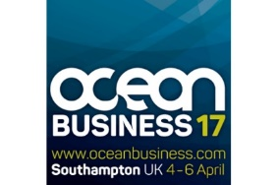](http://www.oceanbusiness.com/)**April 4-6, 2017 (National Oceanography Centre, Southampton, UK)

Ocean Business 2017 is a three-day international exhibition of technology and services backed up by a program of hands-on training and demonstration workshops. There will likely also be meetings on Monday, April 3rd & Friday April 7th with European business and clusters.

*$3,300 includes a small stand in a U.S. BlueTech Pavilion (inclusive of raw space, build-out and signage), + airfare, lodging, meals and incidentals for 1 person (~50% discounted to normal rate). TMA will coordinate all travel and booking arrangements. Each additional person is $3,000.*

Following Ocean Business 2017 in Southampton, UK, join U.S. companies and BlueTech cluster partners in Europe for a trade mission that includes the Ports of Rotterdam, Hamburg and Copenhagen. The mission will include B2B meetings, site visits and VIP networking receptions.

**ROTTERDAm HAMBURG COPENHAGEN**

april 8 – 15, 2017

*$2,000 per person, assuming travelers are already in Europe. TMA will coordinate all travel, bookings and meetings.*

U.S. Maritime Technology export initiative

# application – DUE december 16, 2016

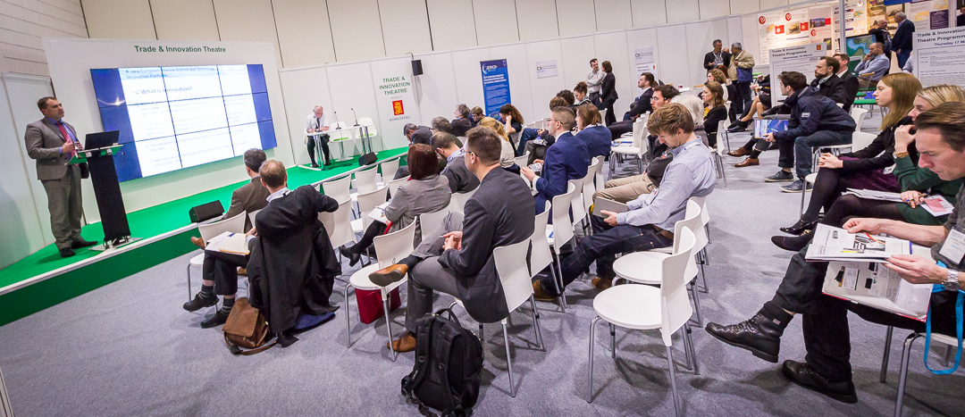

Benefits and responsibilities of participating in the export initiative are listed below.

Benefits

* + - * Pre‐event and pre-mission webinars on foreign markets and industry briefings.
      * Media and publicity about your company’s selection for the Export Initiative.
      * **TMA** will coordinate all aspects related to the trade show pavilion space, and will coordinate all airfare and lodging arrangements for the international trade shows and trade missions.
* Gold Key Matchmaking Services organized by the U.S. Commercial Service and **TMA** to include up to three customized, pre‐screened one‐on‐one meetings with prospective partners.
* Invitations to VIP networking receptions.
* Site visits to local maritime, port and **BlueTech** research facilities when traveling abroad.
* Complimentary membership with **The Maritime Alliance** with related membership benefits.

Responsibilities

* Agree to pay 100% of the fees (heavily discounted to normal rate) at least four weeks in advance of the event start date. Since traveling internationally requires commitments to be made well in advance, **TMA** is unable to provide refunds on cancellations.
* Attend all planned receptions and meetings as agreed.
* Submit a confidential quarterly report to **The Maritime Alliance** to share your export results based on your participation in program activities including number of contacts made, number of leads generated, number and dollar value of sales, contracts formed, and any other examples of your success in developing exports or partnerships abroad. Federal policies require reports for at least 4 quarters following the event.
* If the U.S. International Trade Administration or **The Maritime Alliance** would like to publicize any of your success, we will ask for your approval in writing.